CITY OF MONROVIA
COMMUNITY SERVICES COMMISSION
NOTICE OF MEETING CANCELLATION
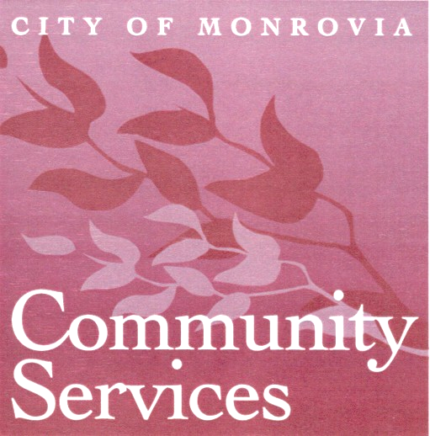

NOTICE IS HEREBY GIVEN

that the

COMMUNITY SERVICES COMMISSION MEETING
FOR AUGUST 11, 2015

HAS BEEN CANCELLED

the
next regularly scheduled meeting is

Tuesday, September 8, 2015
7:00 p.m.
in the Monroe Room at the Community Center

